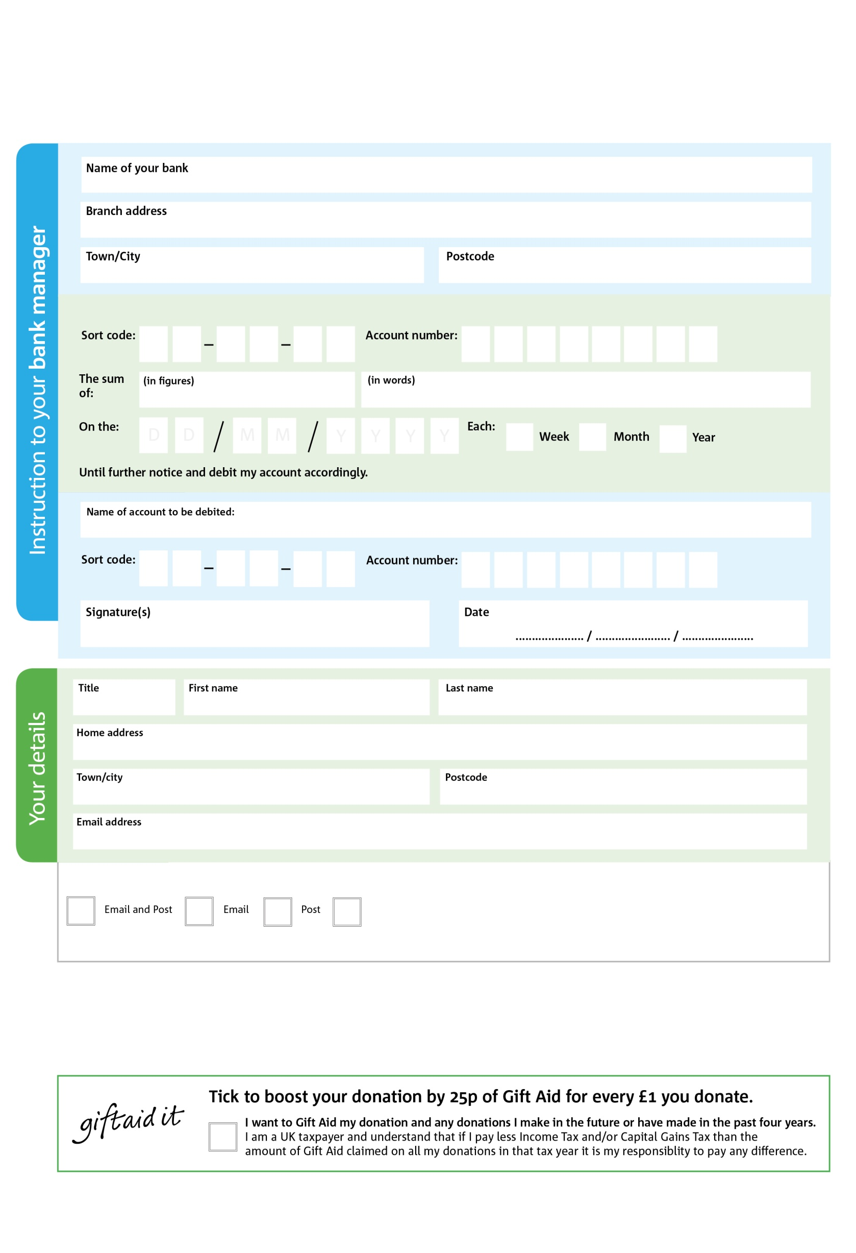

You can change your preferences any time by contacting us on 07896 652209 or emailing us at info@nantwich.foodbank.org.uk

We would love to keep you up to date with information about Nantwich Foodbank. Please tick your preference:

**200 Club Standing Order Mandate**

**nantwich.foodbank.org.uk**

**Please pass this form onto the foodbank, using the foodbank’s address at the bottom, who will save a copy for their records. They will then send it onto your named bank or building society.**

X

V

X

V

X

V

X

V

X

V

X

V

X

V

X

V

X

X

X

X

X

X

I do not wish to receive future communications from Nantwich Foodbank

Please pay XXXXXXXX Foodbank,

**Data protection**

Nantwich Foodbank is committed to protecting your privacy and will process your personal data in accordance with the Data Protection Act 1998. Nantwich Foodbank collects information to keep in touch with you and supply you with information relating to our work. Nantwich Foodbank will never sell or pass your details to anyone who isn’t directly working on our behalf.

Reg. Charity No: 1156950 | Reg. in England & Wales

Nantwich Foodbank, Market Street Church, Market Street, Nantwich, Cheshire, CW5 5DG.

You can change your preferences any time by contacting us on XXXXXXXXXXX or emailing us at XXXX@XXXXXXXXXX.foodbank.org.uk

I do not wish to receive future communications from XXXXXX Foodbank